Artificial Intelligence Coursework
Arran Smedley
School of Computing, Edinburgh Napier University, Edinburgh
40406581
Abstract. The purpose of this coursework is to identify and explain in detail the Dijkstra’s pathfinding algorithm and to write and execute a program in which navigates through cave routes and finds the shortest path within the shortest amount of time through the use of resources and knowledge learned from lectures and practical’s.

- Algorithms

  - Description of Dijkstra's pathfinding algorithm

The Dijkstra’s pathfinding algorithm developed in 1956 by scientist Edsger W. Dijkstra is an algorithm for finding the shortest paths between nodes in a graph, which can be represented in various ways but for this program it is being represented through cave routes and finding the shortest cave route from 1 to 7. Shown in fig. 1.

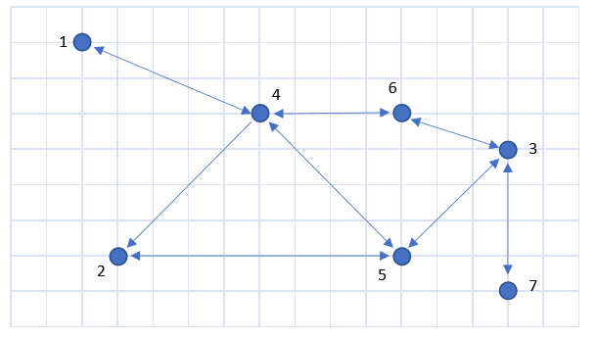

Fig. 1.

The algorithm provided solves the shortest path problem, where we have a start destination, and then can find the minimum distance from there to every other node within a graph. We keep track of every nodes distance from the start node. When we begin we set all nodes distances to maximum. We check each nodes connection and set new distances to equal the parent node plus the cost. If distance is less than the connected current distance, then we set its new distance and parent distance to the current node Then the search continues to find the smallest distance. These distances are the Euclidean distances and represented below. Shown in Fig.2.
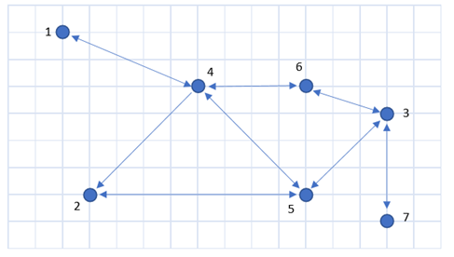
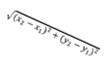

Fig. 2.
So for the robot to travel from the first cavern to the last it would calculate which caves are connected to what through a connection matrix then find the Euclidean distances between each cavern and create measurements to calculate the shortest distance to get from the start to the end. This can be represented in steps to fully understand how this algorithm works.

- Node distance to maximum
- Start node dist to 0
- For each node within path
  - Node with lowest distance is current
  - remove
  - for every node connected
    - if not connected don’t do anything else:
    - Euclidean distance calculation
    - If new distance is less than the connected current distance, set connected node’s distance to new distance and set the connected node’s parent to current node.

  - Description of Second algorithm
The second Algorithm in which I believe to be one of the best algorithms out there as of now and can deem more useful in terms of finding the shortest path within the shortest amount of time for this cave finding program is the A* Algorithm. For a brief comparison the A* Algorithm is a more enhanced Dijkstra’s pathfinding algorithm but with “brains”.

The way this algorithm could be used to solve this problem efficiently and effectively (better than the Dijkstra’s pathfinding algorithm or any other relevant algorithms). Is that it will greedily choose which vertex to explore next according to the value of: f(v)[f(v) = h(v) + g(v)] where h is the heuristic and g is the cost so far. This would be used to find the heuristic between each node within the cave finding program and the g which will be the real cost to reach a node which is presumably the same as Dijkstra’s.

- References
1. Author, Tom Lenaerts.: Article title. AI I: problem solving and search
2. Author, Tom Lenaerts.: Article title. Artificial intelligence: Shortest Path Problem and A*
3. Website: medium.com
4. Website: StackOverflow.com
3. Coursework.: Images used from coursework PDF.

